Mini Project #2

Yanjiao Jia (Contribution 50%)

Yuzhuang Feng (Contribution 50%)

Objective

By using R, to make a map of state-by-state forecast of Hillary Clinton's chance of winning in 2016 presidential election as predicted by FiveThirtyEight.com on Sep 19, 2016.

Procedure

Making a map essentially involves three steps --- getting a shape file for map, getting the data, and plotting.

Before Mapping, we need to install the packages we need to use by use install.packages("packagename"). And loading package with library command. Here the package we need is raster (to get map shape file), ggplot2 (for plotting and miscellaneuous things), ggmap (for plotting), plyr(for merging datasets), scales(to get nice looking legends), maps(the package containing map data). Then we started:

1. Get a shape file of states in the US.
2. Get the data of Hillary Clinton's chance of winning in 2016 presidential election from FiveThirtyEight.com by reading a csv file we save in the working directory we set.
3. Then merge the data with the shape file. Now we get the data called ”usa.df” which contains 8 columns.
4. Create the data file of the abbreviations of states and where they should be plotted, here we exclude Hawaii and Alaska as there is no data for these two sates in the “state” file where we get the shape file.
5. Establish the function to plot. Here we mainly use the “geom_polygon” and “scale_fill_distiller” function to get the main body of our plot, and “theme_nothing”, “labs”, “geom_text” functions to add the abbreviations of states and legend of the plot.
6. Get the break points for different shades, set title and save file.

Plot

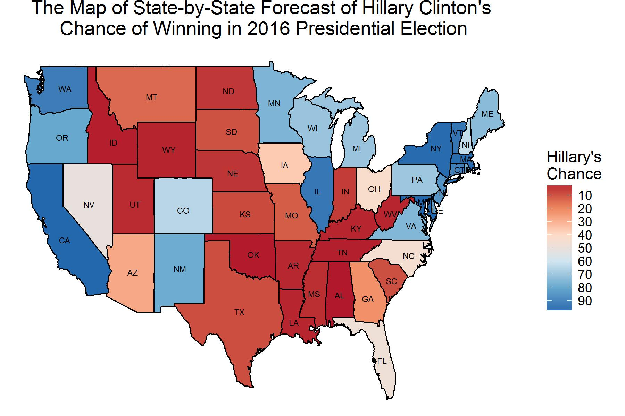

Conclusions

The map shows states of America except Hawaii and Alaska. And the shades of each state on the map presents winning chances as percentages of these two Candidates. Shades of red for Donald Trump and shades of blue for Hillary Clinton. The darker red the state shows, the more percentage of the voters vote for Trump and the darker blue the state shows, the more percentage of the voters vote for Trump. Such a plot can present an intuitive situation on the election.

Appendix: R code

# #####################################################################################

# Making a map using R #

# Making a map essentially involves three steps --- getting a shape file for map,

# getting the data, and plotting. Here we make a map of state-by-state forecast of Hillary

# Clinton's chance of winning in 2016 presidential election as predicted by

# FiveThirtyEight.com on Sep 19, 2016.

#####################################################################################

# Load the package we need

library(raster) # to get map shape file

library(ggplot2) # for plotting and miscellaneuous things

library(ggmap) # for plotting

library(plyr) # for merging datasets

library(scales) # to get nice looking legends

library(maps)# the package containing map data

# Get a shape file of states in the US

usa.df <- map_data("state")

colnames(usa.df)[5] <- "State"

# Get the data to be plotted

usa.dat <- read.table("clinton_chance_sep19_2016.csv", header = TRUE, sep = ",")

usa.dat$State <- tolower(usa.dat$State)

# Merge the data with the shape file

usa.df <- join(usa.df, usa.dat, by = "State", type = "inner")

# Abbreviations of states and where they should be plotted

states <- data.frame(state.center, state.abb) # centers of states and abbreviations

subset <- tolower(state.name) %in% usa.df$State # exclude Hawaii and Alaska

states <- states[subset, ]

# The function to plot

p <- function(data, brks, title) {

ggp <- ggplot() +

# Draw borders of states

geom_polygon(data = data, aes(x = long, y = lat, group = group,

fill=ChanceC), color = "black", size = 0.4) +

# Use shades of red to blue for plotting; trans = "reverse" option

# makes the shades go from light to dark as the percentages increases,

# ensuring that darkest blue = the largest percentage of voters vote for Hillary.

scale_fill_distiller(palette = "RdBu", breaks = brks,

trans = "reverse") +

# Add legend

theme_nothing(legend = TRUE) + labs(title = title, fill = "Hillary's \nChance") +

# Add state abbreviations

geom_text(data = states, aes(x = x, y = y, label = state.abb), size = 2)

return(ggp)

}

# Get the break points for different shades

brks.to.use <- seq(0, 100, by = 10)

figure.title <- "THe Map of State-by-State Forecast of Hillary Clinton's \nchance of Winning in 2016 Presidential Election"

# Save the map to a file to viewing

ggsave(p(usa.df, brks.to.use, figure.title), height = 4, width = 4*1.5,

file = "mini project2.jpg")